ASSIGNMENT REPORT 1
RESEARCH ARTICLE SUMMARY
DATA MINING COURSE



Anggota Kelompok 5:
Gafna Al Faatiha Prabowo (23/516550/PA/22099)
Syafran Abdillah Erdin (23/521752/PA/22444)
Iqbal Pandu Santoso (23/517100/PA/22150)
Dzikran Azka Sajidan (23/516665/PA/22110)

S1 ILMU KOMPUTER
FAKULTAS MATEMATIKA DAN ILMU PENGETAHUAN ALAM
UNIVERSITAS GADJAH MADA
YOGYAKARTA
2026
A Comparative Study of Machine Learning Models for Heart Disease Prediction Using Grid Search and Random Search for Hyperparameter Tuning

Authors: Suman Arshad, Syed Muhammad Junaid Zaidi, Muazzam Ali, M U Hashmi, Abdul Mannan, Affan Ahmad
Journal and Year: Journal of Computing and Biomedical Informatics, Volume 08, Issue 01, 2024
Link to Paper: https://jcbi.org/index.php/Main/article/view/697

I. Research Problem and Research Aims
Research Problem: Heart disease is a major global health issue, and delayed diagnosis increases mortality risk. Traditional diagnosis is time-consuming and may miss subtle patterns in large clinical datasets. The paper addresses how to improve heart-disease prediction using machine learning with proper hyperparameter tuning.
Research Aims:
- Compare multiple classifiers for heart disease prediction.
- Evaluate two hyperparameter optimization methods: Grid Search and Random Search.
- Measure performance using multiple metrics including Precision, Recall, F1, AUC, Kappa, and MCC.
- Identify the most reliable model for clinical decision support.

II. Research Methodology
Diagram of Research Methodology: The study follows a structured workflow consisting of dataset preparation, preprocessing and standardization, model training using multiple classification algorithms, hyperparameter optimization through Grid Search and Random Search, and final evaluation using several performance metrics.
Data Collection: Dataset used is statlog_cleveland_hungary_final.csv for binary classification (heart disease vs no heart disease). Features include age, sex, chest pain type, resting blood pressure, cholesterol, fasting blood sugar, resting ECG, max heart rate, exercise-induced angina, oldpeak, ST slope, and related clinical variables.
Data Exploration: The study discusses mixed feature types (continuous and categorical) and provides metric-comparison plots across search methods for Accuracy, Precision, Recall, F1, AUC, Kappa, and MCC.
Data Preprocessing: Continuous variables were standardized using StandardScaler where the standard deviation and mean are set to one and zero; categorical variables were kept in original representation. The pipeline was prepared to support models sensitive to scale, especially KNN and SVM.
Modeling: The study models heart disease prediction as a binary classification task and compares six approaches, Logistic Regression (as an interpretable linear baseline), K-Nearest Neighbors (a distance-based method sensitive to the choice of k), Support Vector Machine (a margin-based classifier whose effectiveness depends strongly on parameter settings), Random Forest (a bagging-style tree ensemble that aggregates many randomized trees), Gradient Boosting (a sequential ensemble that corrects earlier errors), and a Stacking ensemble that combines multiple base learners through a meta-model to exploit complementary strengths.
A key part of the modeling is systematic hyperparameter optimization using Grid Search and Random Search across these models. Grid Search evaluates all combinations from a predefined parameter grid to find the best-performing configuration but can be computationally expensive as options grow, while Random Search samples parameter combinations from defined ranges, aiming to find strong settings with fewer trials. The overall modeling workflow is to define each model, tune it with one of these search strategies (with validation/cross-validation implied in the pipelines), then select the best-tuned version for final performance comparison.

Evaluation: Metrics used were Accuracy, Precision, Recall, F1 Score, AUC, Cohen's Kappa, and Matthews Correlation Coefficient (MCC). This multi-metric evaluation ensures that the models are judged both on overall correctness and their ability to handle classification errors relevant to medical decision-making.

III. Results and Key Findings
Model Performance:
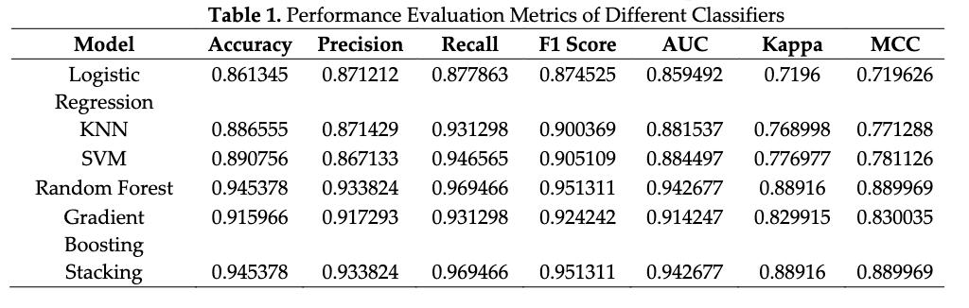Ensemble methods, especially Random Forest and Gradient Boosting, achieved the strongest overall performance. The top reported result is approximately 94.95% accuracy (Grid Search, Random Forest), with Random Search close behind (about 94.54%). Random Forest also reached top or near-top scores across Precision, Recall, F1, AUC, Kappa, and MCC.
Insights: Hyperparameter tuning significantly improved model performance. Multi-metric evaluation gave better clinical reliability than accuracy alone. Ensemble models handled nonlinear interactions better and were more robust. Random Search delivered competitive performance with lower computational cost than full Grid Search in many cases.
Conclusion: Random Forest (and in several comparisons Gradient Boosting) emerged as most reliable for this setting. The research goals were achieved by clearly comparing models and tuning strategies and identifying high-performing options for clinical decision support.

IV. Critique or Reflection
Strengths: Comprehensive classifier comparison, practical comparison of Grid and Random Search, use of clinically relevant metrics including Kappa and MCC, and clear workflow/plot presentation.
Weaknesses: Limited external validation discussion, possible generalization risk from dataset scope, limited class-imbalance/calibration analysis, and limited explainability depth.
Suggestions: Validate on external cohorts, add explainability methods (for example SHAP/LIME), include calibration and decision-curve analysis, and compare with modern boosting variants under the same protocol.

V. Dataset and Code
Dataset: The paper mentions statlog_cleveland_hungary_final.csv. The dataset is available on Kaggle: https://www.kaggle.com/datasets/sid321axn/heart-statlog-cleveland-hungary-final
Code: No explicit public repository link is provided in the reviewed pages. Replication requires the same dataset version and the described preprocessing/tuning pipeline.

